Beaches Chapel Preschool
Parent Handbook
2019-2020

Welcome
Thank you for allowing us the opportunity to care for your child. God has created every child uniquely and every child learns differently. We use diverse teaching styles and combine curriculum from ELMM, Creative, and WEE. All our teachers love teaching small children, are happy to have transparent relationships with our parents concerning their child’s educational needs and are always available to assist you in any way they can. We believe that by instilling God’s love in every child, we help build a foundation for a successful future.
Beaches Chapel Preschool believes and teaches that God is our divine creator, that he sent his son, Jesus Christ, to teach us how God wants us to live, that Jesus died on the cross to pay for our sins, that he rose from the dead, and now sits at the right hand of our Father in Heaven. We teach our students that God loves them and that he makes each person unique and wonderful. We strive to give each child the opportunity to meet their maximum individual, spiritual, social, and academic potentials by keeping class sizes small, by exposing children to Christian teachers who love to teach, who want to be here, and who are excited to teach your children. We firmly believe that learning and play go hand in hand and are indistinguishable, and we sure do know how to play!
Please read this Parent Handbook carefully and in its entirety. Recognize that our Rules and Regulations are in place to promote a clean, safe, fun environment in which to facilitate learning. We require that all parents and preschool staff to always adhere to ALL of our rules. We will hold you to these expectations while your child attends our preschool.
After reading the Parent Handbook, you must sign and return the last page of the Handbook, the Parent Affirmation, BEFORE your child’s first day of school with us. On rare occasion we must amend our rules and regulations, at which time you will be notified and asked to sign a new Parent Affirmation.
School Calendar
BCP is a year-round Preschool. We offer care throughout the school year and the summer months.
******WE NO LONGER OFFER A TUITION FREE WEEK beginning 6-1-19****
While we strive to be open and available more often than our Main Campus, Beaches Chapel Preschool and our VPK Program will be closed on the following days for the remainder of the 2018-2019 school year/Summer and the entire 2019-2020 school year (August – July).
****These closure dates are effective starting July 8th, 2019****
2019 2020
January 21st Martin Luther King Jr. Day (VPK only)  February 18th President’s Day (VPK only)  March 18th – 22nd Spring Break (VPK only)  April 19th-22nd Easter Holiday  May 27th Memorial Day  July 4th and 5th Independence Day  **This is the beginning of the new school closure schedule***** From this point forward, the Preschool and VPK are closed on the same days*****  July 29th- August 2nd Summer Break  August 30th – September 2nd Labor Day  October 31st – November 1st Fall Holiday  November 11th Veterans Day (floating)  November 25th – 29th Thanksgiving Holiday  December 23, 2019 – January 1, 2020 Christmas Break | January 20th MLK Day  February 17th Presidents’ Day  March 16th – 20th Spring Break  April 10th – 13th Easter Holiday  May 25th Memorial Day  June 22nd- 26th Summer Break  July 3rd + 4th Independence Day  Holidays beyond this point have not been determined. You will be notified once completed.

The preschool will notify you if the previous Friday or following Monday will be observed. Tuition is not prorated for holidays and breaks. These days are already factored into tuition pricing.
Drop Off and Pick Up
Class | Earliest Arrival | Latest Arrival | Latest Pick up
Infants, Ones, and Twos | 7:00am | 10:00am | 6:00pm
Threes | 7:00am | 9:00am | 6:00pm
VPK only | 8:15am | 8:25am | 11:30am
VPK Extended | 7:00am | 8:25am | 6:00pm

There will be no dropping off or picking up of any students during our napping hours 11:45am- 2:00pm.
If you require a special consideration for a medical appointment, please speak to the Preschool Director a day in advance.
VPK students are required by the state to be present 80% of VPK hours. This calculates to being able to be absent no more than 3 days per month while VPK is in session (August-May) to maintain state VPK funding. If your VPK student has more than 3 unexcused absences per month, your state funding may be dropped, and you will then be required to pay full tuition cost for your student to remain in our care.
Being late more than 5 minutes to pick up your children incurs a $25.00 charge for every 10 minutes you are late. This cost will not be prorated. This cost must be paid in full by check or money order before your child can return to preschool the next day. If you are consistently late to pick up your child, your enrollment in our preschool may be jeopardized.
Please make time to walk your child to class each day. Please take the time to say hello to the Teacher, relay any needs, and get your child and their things ready for the day. Your child is proud of their accomplishments in class and taking a few extra minutes to recognize these accomplishments mean the world to your child!
We do not permit siblings of our students into the classroom play areas at any time. Please maintain supervision of all siblings when picking up your student.
Notify your child’s teacher or the Director in advance if anyone other than who is on your Approved Pick Up List will be picking up your child. You will have to make this allowance in writing and signed. We will be checking I.D. of this person before allowing them to enter the Preschool. We will not release a child to any individual without proper identification.
Inclement Weather Conditions
If Duval County schools close because of inclement weather, Beaches Chapel School (Main Campus) and Beaches Chapel Preschool will also be closed. All other school weather closings are at the discretion of administration. Please be sure your email and phone numbers are kept current so we can keep in contact with you in the event of evacuation.
Custody/Legal Disputes
Occasionally situations arise when we may deem it unsafe to release your child. Please do not arrive intoxicated or under the influence of drugs that may hinder your judgement and put the safety of your child at risk. Parental and Custody Disputes should be resolved between the parties involved and legal decisions submitted in writing to the Director. Legally, the only orders we can follow are those listed in legal documents and/ or Orders of Protection. Both parents have equal rights under the law unless these rights have been specifically removed by a judge. Parent requests that are not in line with the judge’s orders will not be granted and the local police will be called before the child can be released from the preschool.
Ages and Stages Questionnaire: Development Milestones Monitoring (ASQs)
At least twice a school year your child will be screened with the Ages and Stages Developmental Milestones Questionnaire. The purpose of this testing is to ensure that your child is meeting the minimal developmental milestones for their age. If we find a deficit in an area, we will work with you to provide or to help you seek the help your child may need. You will be sent home a copy of the scoring page for this test and you may make an appointment with your child’s teacher if you would like to review the entire test scoring and notes.
Some of the local agencies that provide free screening and services for children facing challenges in speech, hearing, vision, and behavior include:
Early Learning Coalition (ELC) 904-208-2040 www.earlylearning jax.org
Early Steps (Birth – 36 months of age) 904-360-7022
Child Find (36 months old and up) 904-346-4601
Napping and Resting
All extended day and full-time students have a scheduled nap/resting time on a cot or in a crib daily from 12:00 – 2:00pm. No children will be picked up or dropped off between the times of 11:45am – 2:00pm. Linens will be sent home every Friday to be laundered and must be returned every Monday for weekly use. * All linens must be labeled with your child’s first AND last name*
Class: | Linens needed:
Infants | Fitted Pack and Play sheet, Sleep Sack
Ones and Twos | Fitted Crib sheet, small blanket
Threes and Fours | Fitted Twin sheet, small blanket

NO STUDENTS CAN BE DROPPED OFF OR PICKED UP BETWEEN THE HOURS OF 11:45-2:00PM to allow all children to opportunity to nap/rest. If you need an occasional special consideration be made, please contact the Director.
Lunch and Feeding
It is your responsibility to send your child a healthy lunch, 2 snacks, and a reusable water bottle (filled only with plain water) each day. Be sure to include an icepack in your child’s lunch if it requires refrigeration. We do not provide refrigeration. We do not heat food. If you would like your child to have warm food, please warm it at home and send it in a thermos container. WE DO NOT PROVIDE FOOD SERVICES. Please let us know of any allergies your child may have, as we do food related activities, parties, and crafts throughout the year. Please do not send candy in your child’s lunch. Please follow the USDA Food Recommendations when packing your child’s lunch. Per DCF policy all lunch boxes, bowls, spoons, water bottles, and food containers must be labeled with your child’s first and last name. Please do not send glass containers.
Repeated inability to provide your child with a healthy lunch and snacks will result in a Parent/Director Conference to discuss how we may better guide you to outside programs that may assist you in providing healthy foods for your child and family.
Parties/Celebrations
We love to celebrate special occasions with your child! If you would like to send in a special treat to share with the class, please talk to your child’s teacher about any allergies present in their room and let the teacher know what day you plan on sending in the treats.
We do have parties for many occasions/holidays throughout the year. Your child’s teacher will post a list of needed items on her classroom door or possibly contact you via email or text. If you are willing and able to donate, we welcome you to do so.
Labeling
ALL of your child’s belongings (with the exception of individual diapers) must be labeled with their first and last name per DCF code. Label all lunch bags, food containers, bottles and bottle caps, water cups, sippy cups, wipes, baby food, utensils, extra clothing including shoes, coats, mittens, hats, backpacks, sheets, blankets and everything else you can fit a label on. You may consider ordering labels online, or masking tape and a Sharpie marker work just as well. If items are sent in un-labelled, we will label them with a Sharpie marker. You may order premade preschool labels online if you’d prefer. A few of our favorites are: www.namebubbles.com www.mabelslabels.com
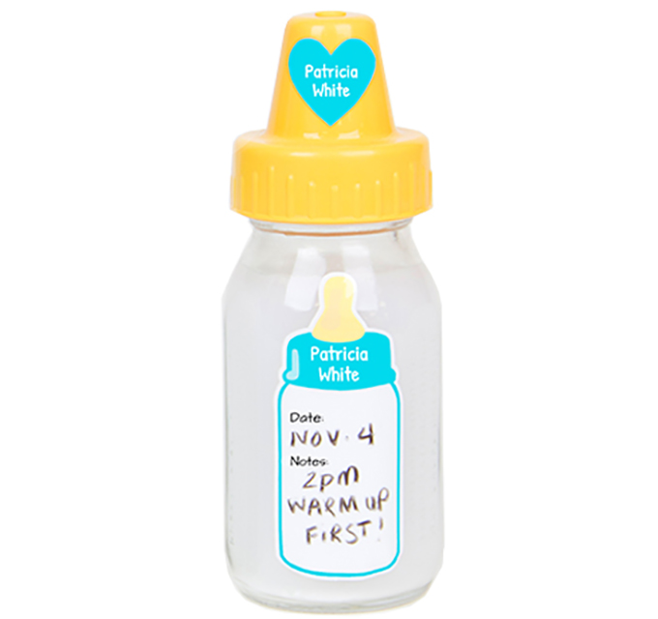 | 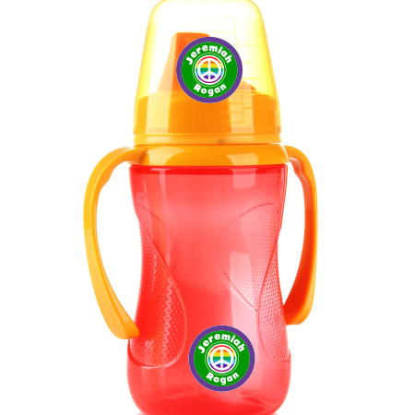

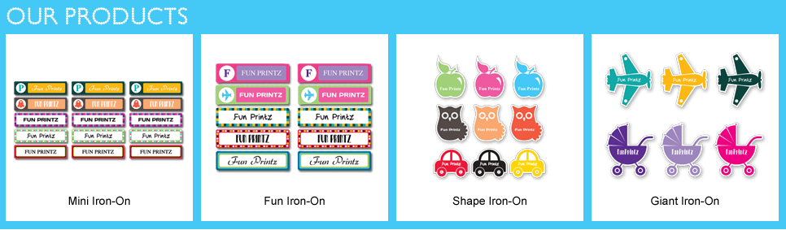

Dress Code
Children are required to wear weather appropriate play clothes. We do a lot of messy activities that may cause your dressy clothes to get stained. Only wear clothes to school that you are ok with getting dirty. If wearing a dress, your child must wear shorts, bike shorts, or pants underneath to provide modesty.
Children are required to wear socks and fully enclosed tennis shoes each day. Crocs, flip flops, and sandals are not permitted.
We all have Accidents
Occasionally a child may have an “Accident.” Please send in a seasonally appropriate complete changes of clothing including a shirt, underwear, pants/shorts, socks, and shoes. You will need to send in more extra clothing daily ( 5 sets daily) if your child is potty training- see your child’s teacher for individual needs.
All clothing and shoes must be labeled with your child’s first and last name.
Illness
Beaches Chapel Preschool strictly follows the Florida Statute and Day Care Licensing Policies on Illness. We love your children and want everyone to stay healthy. Your child should stay home if they are sick to prevent the spreading of illness to classmates and teachers. Your child should stay home if:
  - They are running a temperature of 100.1 degrees or higher. We check temperatures under arm and on the forehead. Your child may return to school when they have been fever free for 24 hours without medication or if you have a doctor’s note stating that your child isn’t contagious.
  - They have loose stool/diarrhea more than one time in 24 hours. Your child may return to school when they have not had diarrhea for 24 hours without medication or if you have a doctor’s note stating that your child is not contagious.
  - They have Pink Eye. Pink Eye is highly contagious and requires medicated drops for 24 hours before your child can return to school.
  - They have severe coughing
  - They have head lice – If your child is frequently scratching their head, watch for signs of head lice. After treating with appropriate lice killing shampoo or undergoing a heated lice removal treatment, please bring your empty box of shampoo or receipt from the lice removal treatment before your child can return to school.
  - They have difficulty breathing
  - They have constant green or yellow mucus from the nose. Your child may return with a doctor’s note saying they are not contagious.
  - They have Hand, Foot, and Mouth Disease – this is extremely contagious, and your child is unable to return to school until the blisters have popped and scabbed. This should be 7-10 days after the outbreak.
This is not a conclusive list. If a child comes to school sick, a Parent will be contacted for immediate pick-up.

Medications
ALL MEDICATIONS REQUIRE A COMPLETED AND SIGNED AUTHORIZATION FORM. These forms are available in your child’s classroom and from the Director. You may consider taking a few forms home with you to fill out for future use to save time at drop off.
- All medications must be administered from the original container with the label intact and legible.
- All prescription medication must be identified with the child’s name on the original label.
- No medication will be given after the expiration date on the bottle.
- Label restrictions and guidelines cannot be altered without a Doctor’s Statement.
- Prescription medication can only be given to the child whose name is on the bottle, unless a doctor’s note dictates differently.
- Do not add medication to your child’s cup or bottle.
- All medication must be age appropriate and administered according to the directions on the label.
- Diaper creams and Insect Repellant ARE considered medications by DCF and require Medication Authorization Forms to be filled out and signed by the Parent.
Tuition Payments
The Registration Fee of $75.00 per family is due upon registration.
Please read this carefully:
Tuition is due on the FIRST day of EACH WEEK. If tuition is not paid in full on the first day of the week, a $25.00 late fee will be assessed on the second day of the week. If tuition and any late fees are not paid by the third day of the week, your child may not return to school until payment has been made in full. There will be NO PRORATING of days due to late payment.
**********Current Rates- Due for a rate increase this May 2019*******************
Infant Room | $225.00 per week
Ones Room | $200.00 per week
Twos and Threes Room | $200.00 per week
Fours Room (without VPK) | $200.00 per week
Fours Room (with VPK) 7:00am-6:00pm | $125.00 per week
We offer a 10% sibling discount or a 10% military discount. Discounts may not be combined.

Payments may be made by check or money order (payable to Beaches Chapel Preschool) at our Preschool Drop Box. Please be sure to write your child’s name on the memo line of your check or money order to ensure credit is given to the correct account. We do not accept cash at the Preschool Drop Box. Please make any cash payments directly to the Main Campus Church Office, 610 Florida Blvd., with Korrie Morris (904) 241-4211 to receive a receipt. Please do not attempt to give payment to any teachers, they cannot accept money.
Parking
Please use the parking spots in front of the Preschool and around the side of the building when dropping off your child. Please do not park directly in the driveway blocking the flow of traffic, and potentially any emergency vehicles.
SMOKING IS PROHIBITED ON SCHOOL GROUNDS.
Infants
Parents of infants will supply all food, milk, formula, bottles, breastmilk, snacks, diapers, wipes, diaper creams, and extra clothing for your child. Everything must be labeled with your child’s first and last names- including everything listed above with the exception of individual diapers. Your child will have their own diapering bin.
All bottles of formula must arrive pre- mixed and in bottles. Breastmilk may be brought in frozen flat along with clean bottles separate. Any finger foods, cookies, teething biscuits, etc. must be fully prepared and cut up at home and be ready to serve.
Each infant is required to arrive with a minimum of 4 – 4 ounce (equaling 16 ounces) bottles daily in addition to any finger foods or baby foods they are eating.
** Infants must already be accustomed to feeding from a bottle before
you leave them in our care. **
At 8 months of age, we require your infant wear hard soled shoes with socks daily- no crib shoes, Crocs, or sandals. You are welcome to leave the shoes and socks in the classroom for daily use.
WE CHARGE $2.00 PER DIAPER FOR THE USE OF OUR EXTRA DIAPERS if your child’s supply runs out. Your teacher will keep you well informed of diapering needs. Your child is changed every 2 hours, unless a bowel movement occurs.
Sleeping Infants
DCF code does not allow the use of blankets, pillows, toys, or sound machines in the crib with your infant. If you would like your child to be covered while sleeping, please provide a size appropriate sleep sack.
Potty Training
Potty training starts at home. Once your child has had ongoing success with potty training at home, we will gladly then assist them with potty training here at school. All children must be completely potty trained before entering the 3- year-old classroom.
“Complete Potty Training” = Knowing that you must go potty, taking yourself into the bathroom, removing own clothing, using the potty, wiping, pulling up clothing, flushing the potty, washing hands, and walking back to the classroom.
Indicators that you child may be ready to potty train include:
- Naming Body functions
- Expressing the need to be changed
- Actively participating in potty time
- Using the potty successfully at home
When both parents and teachers agree about a child’s readiness, your child will need to bring with them each day:
- 5 pairs of underwear
- 5 complete, weather appropriate changes of clothing including socks and shoes
- A small supply of pull-ups for unsuccessful days
Please do not send your child with these items until you have discussed your potty- training plan with your child’s teacher. We will send soiled clothing home daily. Please re-supply as needed.
Biting Policy
Biting is a normal phase that non-verbal children experience between 13-24 months of age. For health and safety reasons, we take biting seriously. We will make every attempt to redirect a child who is biting, but if a child bites another person (child/or adult) more than twice in one day, parents will be called to remove the child from preschool for the remainder of the day. If biting continues and we feel like we have made every accommodation to stifle the behavior, the biting student will be withdrawn from our preschool.
Child Abuse and Neglect
ALL teachers and child care workers are mandated by the state of Florida to report ANY and ALL suspicion of child abuse and/or neglect to The Department of Children and Family Services. We take this responsibility very seriously. If you ever have the need to report abuse and/or neglect, PLEASE DON’T HESITATE TO CALL:
The Department of Children and Families Abuse Hotline
Phone: 1-800-962-2873
Fax: 1-800-914-0004
Reports are accepted 24 hours a day, seven days a week. You may remain anonymous.
Discipline
To maintain a peaceful, loving, and healthy classroom environment we must provide reasonable rules with appropriate consequences. Our teachers model their behavior in the manner that we wish children to follow. We try to eliminate any problems before they occur. We have a ZERO TOLERANCE POLICY FOR CHILDREN WHO PHYSICALLY HURT OTHERS. Just as you wouldn’t want your child hurt, neither do other parents. If a child is acting in a manner that threatens or hurts other students, teachers, staff, or self, the Parents will be called to remove the child from care for the day and a Parent/Teacher Conference will be set to discuss possible solutions to resolve the issue. Our discipline here at the preschool is legally limited to:
- Verbal Warning (“Please do not use your hands to hit my friends. Please use gentle hands.”)
- Redirection (The child would be moved along to another activity)
- Time out/Removal from the classroom
- Visit to speak with the Director
- Parent/Teacher conference
Per the Department of Children and Families Child Care Facility Handbook, to be used in conjunction with Sections 402.26-402.319, Florida Statutes, and incorporated by reference in rule 65C-22.001 of the Florida Administrative Code:
Item 2.8 Child Discipline Reads as follows:
- The child care facility shall adopt a discipline policy consistent with Section 402.305(12), Florida Statutes, including standards that prohibit children from being subjected to discipline which is severe, humiliating, frightening, or associated with food, rest, or toileting. Spanking or any other form of physical punishment is prohibited.
You can visit www.myflfamilies.com if you would like to view a full version of the Child Care Facility Handbook Rules and Regulations.
Incident/Accident Reports
Incident Reports are written when your child injures another child, gets injured by another child, or has ongoing behavioral issues not conducive of our classroom environment. Accident Reports are written when your child has an accident independent of other children and it results in self injury. Parents must review and sign the Incident/Accident reports when picking up their child daily. A copy will be made to the parent by the next business day.
If a child receives more than 2 Incident Reports in a day for the same issue (i.e., biting, spitting, hitting others, hurting others, etc.) the parent will be called to remove the child from the preschool for the remainder of the day. Likewise, if a child poses an ongoing distraction, behaviorally or physically, the parent will be called to remove the student from the preschool for the day. Ongoing distraction and behavioral issues that are unable to be resolved will lead to the student being dismissed from our preschool.
Aggression and Tantrums
Aggression toward others and tantrums are more common when children are unable to communicate their needs effectively whether verbally challenged with an impairment, or just too young to speak. We will work closely with parents to help see that the child’s communication needs are improved upon and that aggression and subsequent tantrums are resolved. When aggressive behavior and tantrums are unable to be resolved or become harmful to other children/staff and distracting to the overall classroom environment, the student’s enrollment at our preschool will be in jeopardy and potentially dismissed as deemed necessary.
Social Media Policy
Parents should remember that all internet posting are permanent, able to be duplicated, and may go viral. Avoid actions and discussions that could harm the interest in Beaches Chapel Preschool, our faith, or other persons. Harassment, threats, intimidation, ethnical slurs, personal insults, pornography, obscenity, racial or religious intolerance, abuse, or any other form of behavior prohibited by law is not allowed by BCP families. Families must always conduct themselves on the internet in a way that shows the value and character of BCP. It is your responsibility to post only photographs that are above reproach or any appearance of misconduct or questionable character. If you have any questions about this policy, please contact the Pastor of School Administration- Edi Wohlgemuth @ 904-241-4211. Failure to comply with this Social Media Policy will result in immediate disenrollment from BCP.
Miscellaneous Information
- Please always notify the Preschool if you have any changes in address, phone number, email addresses, or changes in medications. Please also let us know about any major changes that your child may be processing- divorce, death, moving, new pets, etc. We have found that the smallest changes have huge impacts on our small ones.
- For safety and insurance reasons, NO ONE IS ALLOWED on our school grounds, playgrounds, or back field area after school hours unaccompanied by a preschool employee.
We are dedicated to providing your young children with a happy, safe, positive, fun, and encouraging introduction to school. This is most frequently accomplished when teachers and parents work together. If we feel that we are not the most appropriate place or if we are unable to offer services your child needs, we reserve the right to dismiss your child from our preschool and request that you find another preschool program for your child.

Beaches Chapel Preschool
Parent Affirmation
2019-2020
Student’s Name:_________________________________________________
Student’s Name:_________________________________________________
Beaches Chapel Preschool desires families to be of one mind with the preschool staff in understanding the policies and purpose of our preschool. Consequently, we ask that at least one Parent affirm that he/she has read the Beaches Chapel Preschool Handbook including the Disciplinary Policy and agrees to support the preschool in matters that may arise. Parents need to read the Handbook in its entirety and initial/sign the appropriate spaces indicating that the handbook has been read and that an agreement has been made to support the enforcement of all policies and procedures, again, including our Disciplinary Policy which remains compliant with the Florida Statutes Sections 402.26-402.319 and incorporated by reference in rule 65C-22.001 of the Florida Administrative Code.
This signed Affirmation must be signed and returned in by your child’s first day of school with us, or by the next school day if this is a revision of the Parent Handbook.
Initial:_______ Date:_______ Section 65C-22.006 (2), F.A.C., requires a current physical examination (Form 3040) and immunization record (Form 680 or 681). I verify that I am willing to remain in full compliance with this Physical Examination and Immunization requirement.
Initial:_______Date:_______Florida Statute requires that parents receive a copy of the Childcare Facility Brochure and the Influenza Virus Brochure. You must sign and return the Influenza Brochure.
Initial:_______Date:_______Florida Statute requires that parents/guardians be notified in writing of the Disciplinary Practices used by the childcare facility. I have read, understand, and will support the preschool’s Disciplinary Policies and Procedures.
Initial:_______Date:_______I have read and understand the Illness Policy.
Initial:_______Date:_______I have read and understand the Medications Policy.
Initial:_______Date:_______I have received and read the Distracted Adult Driver Brochure.
Initial:_______Date:_______I have received and read the Rilya Wilson Act Brochure.
Initial:_______Date:_______I have received and read the Preschool Closure Dates 2019-2020.
Initial:_______Date:_______I have received and read the Tuition Increase/Payment Information. Tuition increase takes effect June 1, 2019.
Initial:_______Date:_______I have received, read, and agree to abide by the rules and regulations in the Beaches Chapel Preschool Parent Handbook.

Parent Signature:__________________________________________________ Date:___________________

